VBA Challenge Week 2 Homework Outputs Jim Worlein

2016

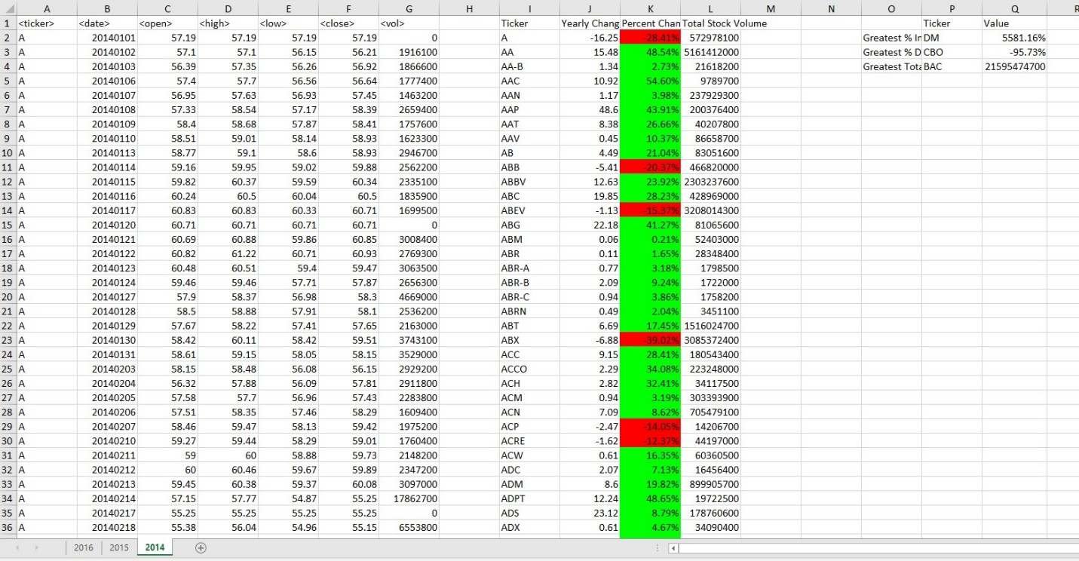

2015

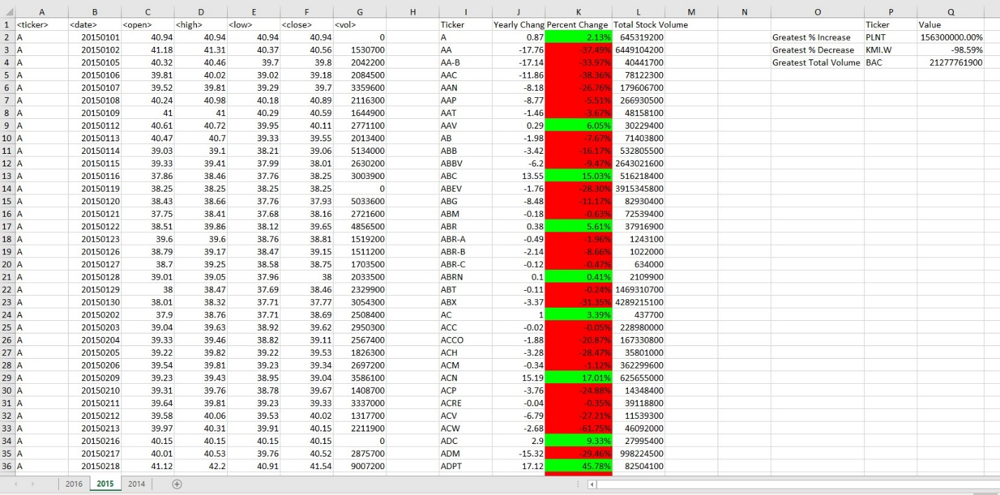

2014

